Deretchin Kindness Rocks Project
2020-21
Three years ago, our 6th grade Student Council participated in the” #Kindness Rocks@Deretchin” project. This project, which originated from one person who wanted to make a positive impact in her community, is intended to help spread kindness and encouragement to others. The 6th graders helped us gather and paint over 200 rocks. Each 6th grader then decorated their rock with an inspiring or uplifting statement. These rocks were then placed in front of our school by the flagpole. Since then, our rock garden has grown each year! During our quarantine for Covid19 last spring, our kids and community were continuing to make and share rocks all around The Woodlands!

Our mission is a simple one: 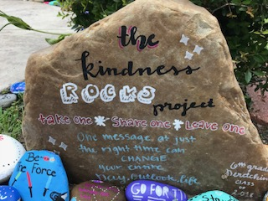

Thank you to our community sponsor, A&A Stone and Masonry on FM 1488!!

