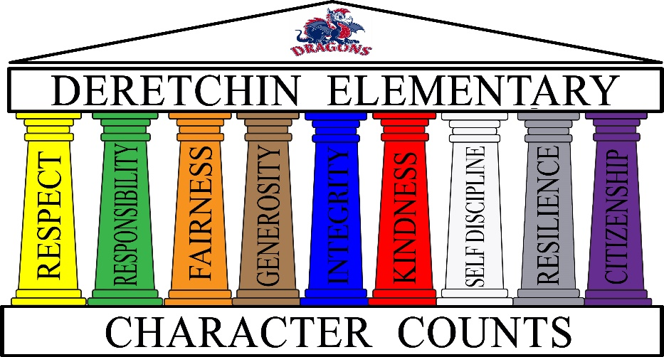

Character Counts at Deretchin!

At Deretchin we strive to teach and enrich the “whole” child, not only through academics, but also through character education, social/emotional skills, and opportunities for developing habits of leadership and citizenship. We believe strongly that “Academics + Character = SUCCESS”, and our counseling program is designed to support this goal. Each month we will focus on one of our nine “Pillars of Character”. The 9 pillars are Respect, Responsibility, Fairness, Generosity, Integrity, Kindness, Self-Discipline, Resilience, and Citizenship. Each pillar is represented by a specific color that helps students remember what that character trait means (i.e. Respect pillar is yellow which stands for the “golden rule”). Within each Pillar are embedded specific “Habits” that teach students what that character trait “sounds like”, “looks like”, and “feels like”. The entire school community builds upon these traits and habits through modeling and reinforcing positive behaviors using “Yellow Tickets”. Teachers will do weekly drawings of tickets which are tied to non-tangible rewards. Each month one student per home base will be chosen by their teacher to be honored at our “Spotlight” program, which parents are invited. Our daily Morning Meetings provide an intentional place for students to make connections with others, and address critical social/emotional health.
There are many other opportunities for Deretchin students to grow in leadership skills including the Ambassador program, Dragons-to-Dragons mentoring program, 4th-6th grade Student Council and committees, just to name a few. The counselors and teachers work together to support student learning and character, and are available to students and parents at any time to be more successful.
We are ALL character teachers at Deretchin!

