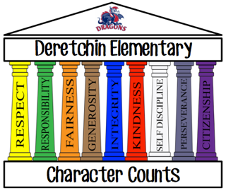

Spotlight Ceremony

Each month homebase teachers, K-6, will choose one student who exhibits that month’s character pillar consistently or who has made a difference in their classroom. This particular honor is celebrated by a brief program which parents are invited to attend. Our 6th Grade Ambassadors will read brief comments from their homebase teacher that explains why they were chosen. Students will then be presented a certificate that is signed by the principal and has their teacher’s comments written on it. One day each month, we celebrate that month’s character trait by wearing the color of the pillar. The color of the pillar helps remind students of what the pillar stands for (i.e. Respect is yellow/gold to remind us of the “golden rule”). This is a great visual of what an impact we all have individually and together if we all “show our true colors” each day.

